# JS ASSIGNMENT

1. **Basics Questions.**
   1. What is an identifier? How to declare an identifier using C programming,
   2. What is variable?
   3. What is data type? Explain the types of data types using C Programming
   4. What is function? Explain the types of functions with an example.
   5. What is an operator? Explain the types of operators with an example.
   6. What are conditional statements? Explain the types of conditional statements with an example
   7. What are loop statements? Explain the types of loop statements with an example
   8. What is a class in C++? Example with syntax.
   9. What is an object? Explain with an example
2. **JavaScript Basic Questions**
   1. Data types in JavaScript.
   2. What is undefined?
   3. Difference between undefined and null.
   4. Difference between static value and constant value.
   5. Difference between document.write() and document.writeln().
   6. Difference between innerHTML and innerText.
   7. Where should we keep our script tag in HTML document explain each scenario?
   8. What is global scope and local scope variables?
3. **Programming questions. (Lab Questions)**
4. Program to find out whether a given year is leap year or not?
5. Program to convert temperature from Fahrenheit to Celsius and Celsius to Fahrenheit.
6. Program to check the sign of a given number.
7. Check whether a given number is even or odd.
8. Check whether the triangle is equilateral, scalene, or isosceles?
9. Program to check whether a character is alphabet or not.
10. Program to check vowel or consonants.
11. Program to print a number of days in a month?
12. Program to check whether the triangle is valid or not if angles are given.
13. Program to enter student marks and find percentage and grade. A college has the following rules for the grading system:
14. Below 25 – F
15. 25 to 45 – E
16. 45 to 50 – D
17. 50 to 60 – C
18. 60 to 80 – B
19. 80 to 95 – A
20. Above 95 – A+
21. **Loop**
    1. Difference between while loop and do while loop.
    2. Difference between while loop and for loop.
    3. Define the above loops use case scenarios
22. **Create a pattern as shown in the picture**

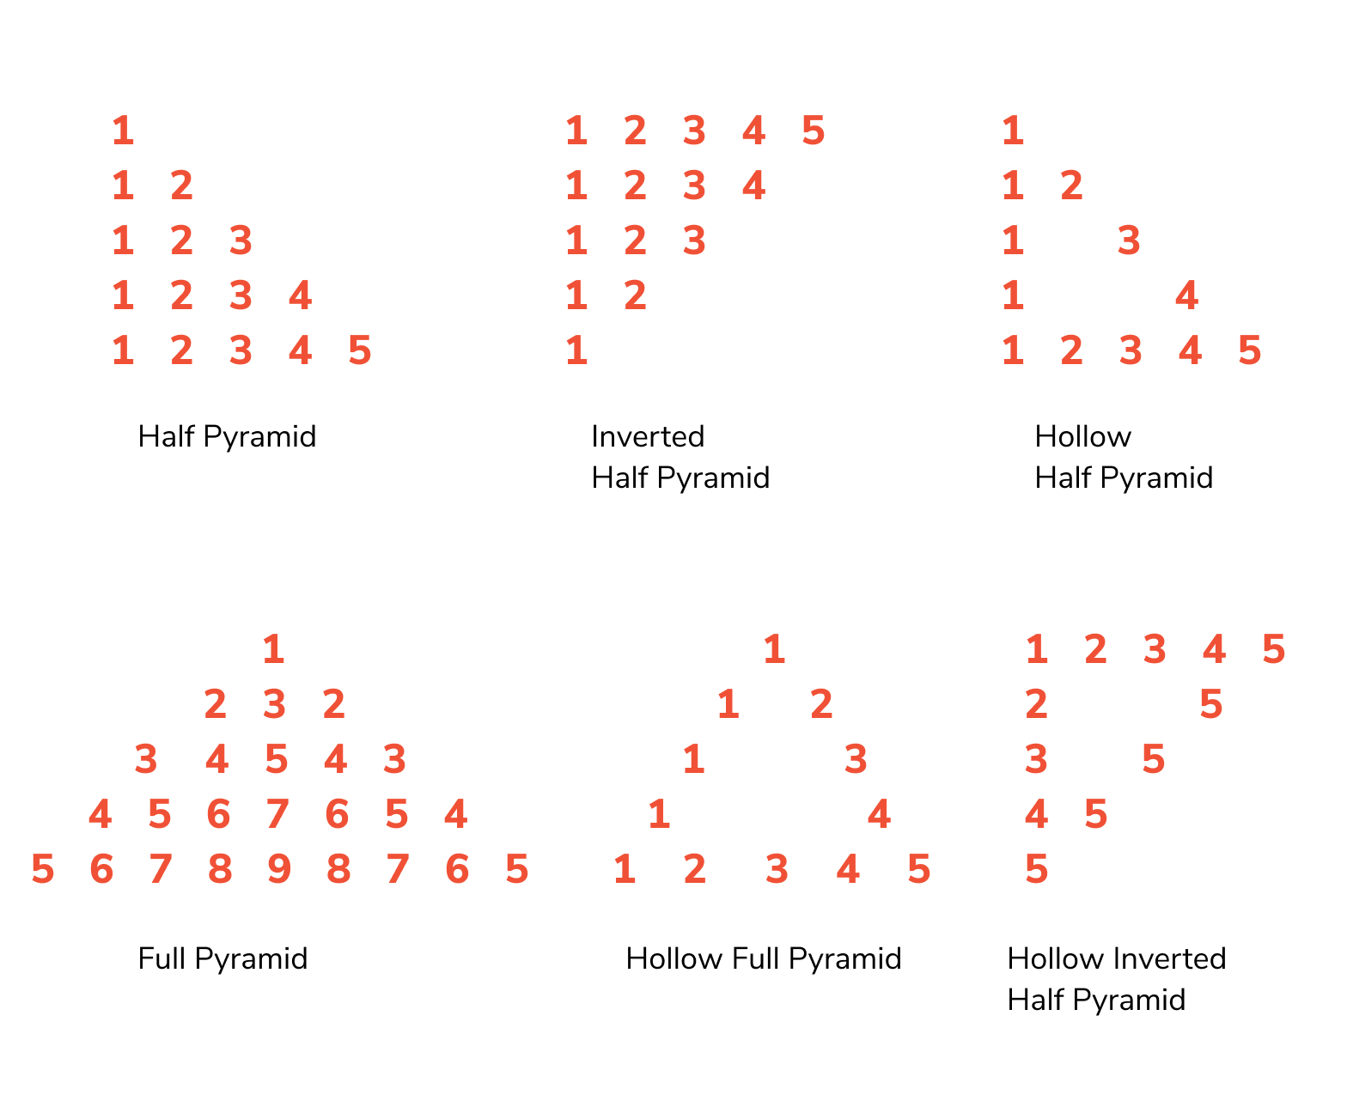

# 5.

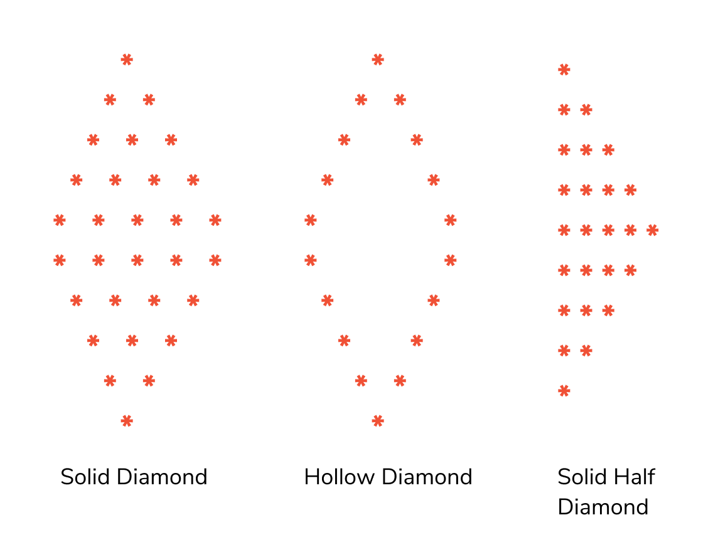

# 6. JavaScript Advanced Question

1. Build an image slider using JavaScript.
2. Build a sound button page of your choice.
3. Build Tetris game using JavaScript.
4. Build 2048
5. Form validation using JavaScript and regex. add beautiful effects for it using CSS (ex: - Glassmorphism)
6. Try parallax effect (CSS)
7. Learn ES6+ methods to get familiar in React Js (Rest operator, spread operator, Destructing, Map, Filter, Reduce and other array methods, Classes, this) there are many ... keep learning
8. CRUD operation using JavaScript object.
9. E-commerce responsive project using HTML, CSS and JS.

# 7. JavaScript Assignment Questions

